Biology 203
Lab 2

Phylogenetic Trees
In today’s lab you will be constructing two phylogenetic trees using the maximum likelihood method and two mitochondrial genes. Rather than selecting a model of evolution and adjusting statistical parameters, as is typical when building a phylogeny using maximum likelihood, you will be using a simpler “one click” method.

Background
The Dodo (Raphus cucullatus) was a flightless bird native to the island of Mauritius. It became extinct in the 1600’s and is one of the most famous examples of human-induced extinction. Having evolved in the absence of significant predators, it was fearless of humans and was extirpated by a combination of hunting and nest predation by human-introduced pigs, monkeys, cats, rats, and dogs.

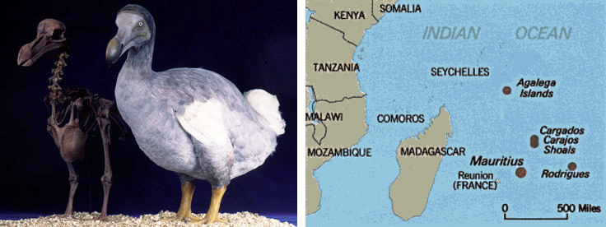

It has been variously suggested that Dodo’s were a type of parrot, ostrich, rail, albatross, or vulture (Owen 1846). Theodore Reinhardt suggested that it was most closely related to pigeons, which was later supported after the examination of the Oxford museum specimen (Strickland and Melville 1848). While this theory has been generally accepted, the complete evolutionary history of the Dodo remained unknown until recently. In this lab, you will use genetic data from museum specimens to reconstruct the Dodo phylogeny.
Phylogenetic Tree 1: Part 1
You have been given a data file (named “cytb”) with the species names and genetic sequences of the cytochrome b gene from the mitochondria of 35 species of birds. The data is in FASTA format, which can be seen in the following example:
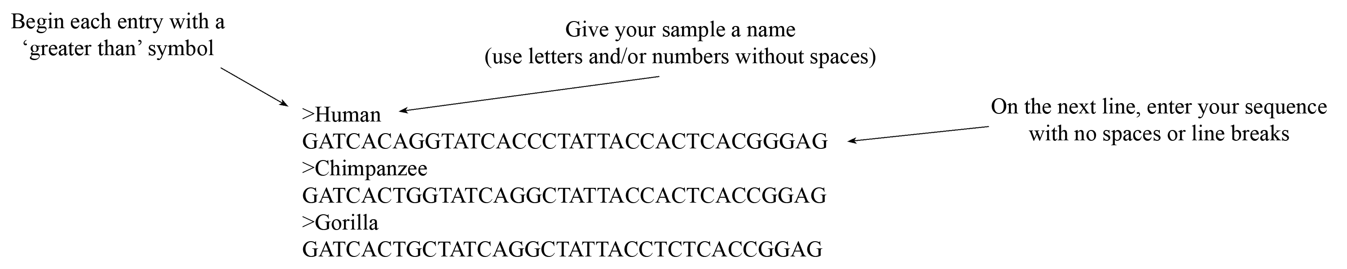

Before creating your tree, your sequence data must first be aligned. To do this, you will use the program Muscle.
- In your browser, go to the following website: http://mobyle.pasteur.fr
- In the “Programs” column to the left, click “alignment”.
- Under “alignment”, click “multiple”.
- Under “multiple”, click “muscle”.
- Open your cytb file using Text Editor (PC) or TextEdit (Mac), copy all of the data, and paste it in the box below “Enter your data below:”. Alternatively, you may click the “upload” tab, click the “Browse…” button, and select your cytb file.
- Click “Run”.
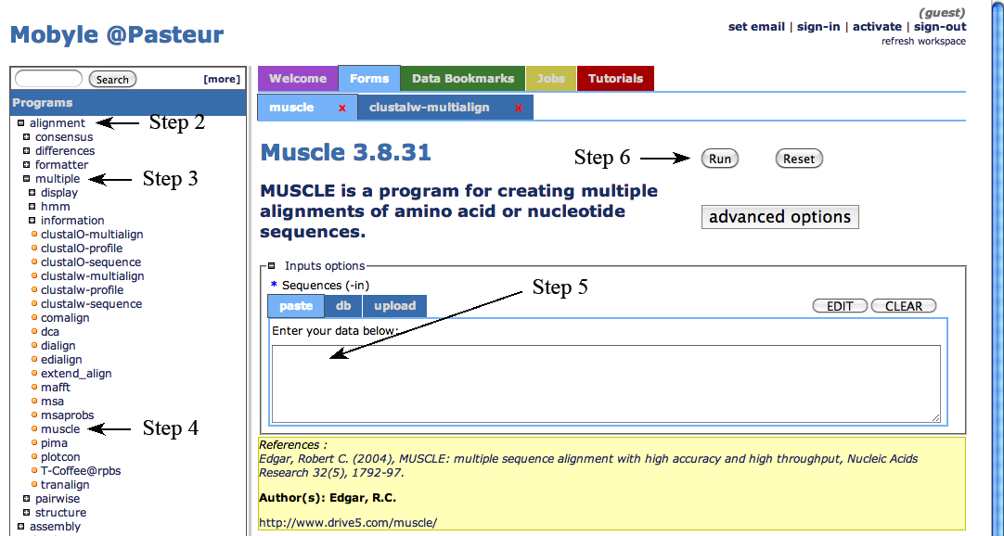
- Enter your email address when prompted, click “Ok”.
- Select and copy the results in the “Alignment” box. 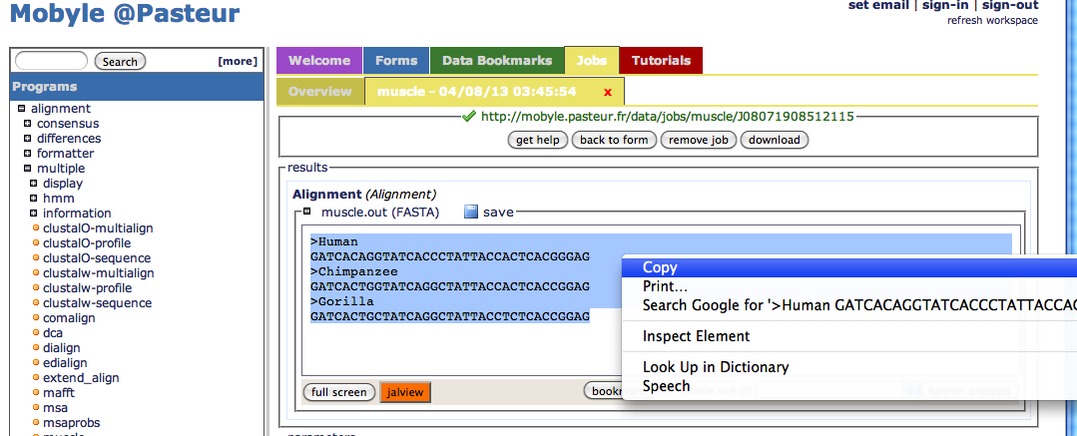
- Open a new file in Text Editor (PC) or TextEdit (Mac) and paste your aligned data. Save as: cytb_aligned. Alternatively, click “save” under “Alignment”; rename your file.

You will now use your aligned data to build a tree. You will use the program PhyML.
- In your browser, go to the following website: http://www.phylogeny.fr
- Under “Phylogeny analysis” (about half way down the page), click on “One Click”.
- Open your cytb_aligned file, copy all of the data, and paste it in the box below “Or paste it here”. Alternatively, you may click the “Browse…” button and select your file.
- Click the “Submit” button at the bottom of the page.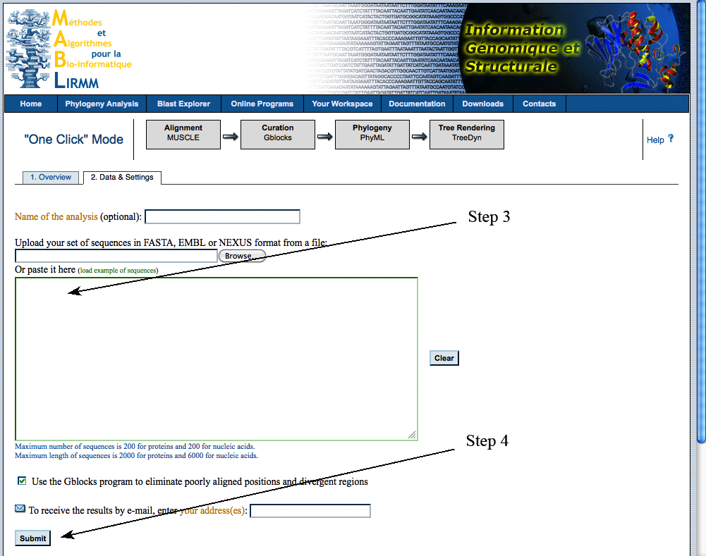
Draw your tree:

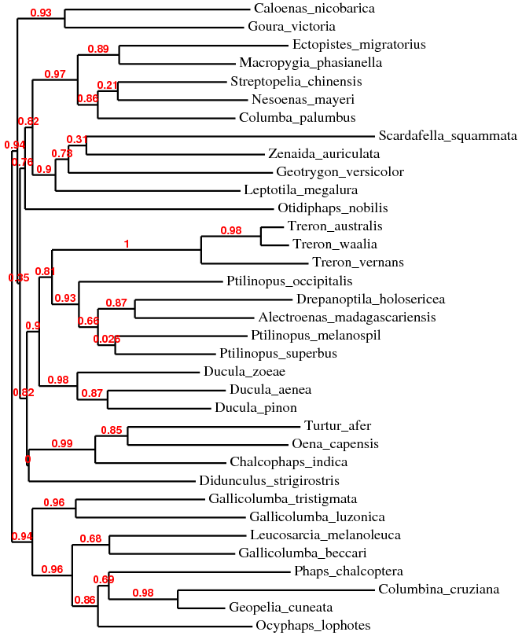

Phylogenetic Tree 1: Part 2
Next, you will add additional taxa to your tree: the Dodo (Raphus cucullatus) from Mauritius island and it’s presumed relative the Rodrigues Solitaire (Pezophaps solitaria) from Rodrigues island. Both of these birds have been extinct for hundreds of years but DNA was isolated from specimens originally collected for (and preserved in) natural history museums.

You will download the data from GenBank (the national repository for genetic data) and add it to your cytb file. Through GenBank, you can find genetic data by searching for the species and gene names, the name of a journal article (if there is a published article for which sequences have been deposited in GenBank), or the Accession number (each sample’s unique ID) if you know it.

- In your browser, go to the following website: http://www.ncbi.nlm.nih.gov/genbank
- Verify that the pull-down menu at the top of the page is set for “Nucleotide”.
- Type the following Accession number in the search bar and click “Search”: AF483338.1

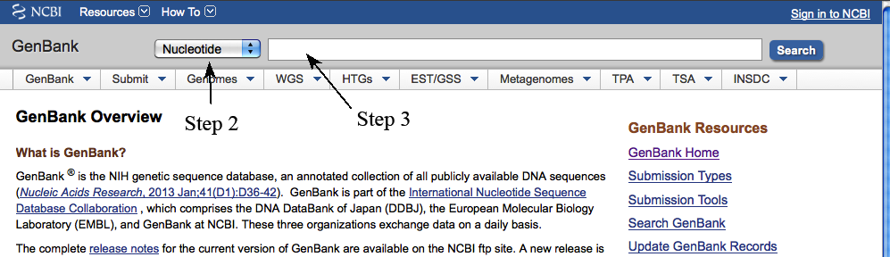

What species did the data come from?
Raphus cucullatus (Dodo)

What gene is this?
cytochrome b (cytb)

What is the title of the journal article that this sequence was used for?
Flight of the Dodo

What journal did this article appear in? Science
List the authors of the article:
Beth Shapiro, Dean Sibthorpe, Andrew Rambaut, Jeremy Austin, Graham Wragg, Olaf Bininda-Emonds, Patricia Lee, Alan Cooper

- Click “FASTA” under the GenBank Accession number.
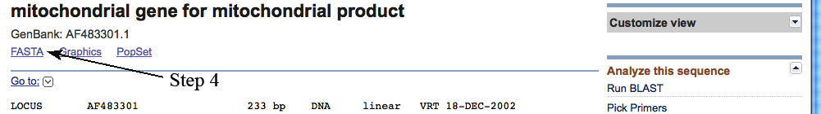

- Copy the FASTA sequence and paste at the end of your cytb file (you may want to change the name to match the format of the rest of the file).
- Repeat Steps 3-5 with Accession number: AF483337.1
- Save the file as cytb-2.

What species did the data come from?
Pezophaps solitaria (Rodrigues Solitaire)

What gene is this?
cytochrome b (cytb)

Is this sequence data from the same journal article as the previous sequence?
Yes

Now you will use your new data to build another phylogeny.
- Align your data: using your cytb-2 file, follow Steps 1-9 on Pages 2 and 3.
- Build your tree: using your cytb-2_aligned file, follow Steps 1-5 on Pages 3 and 4.
Draw your tree:
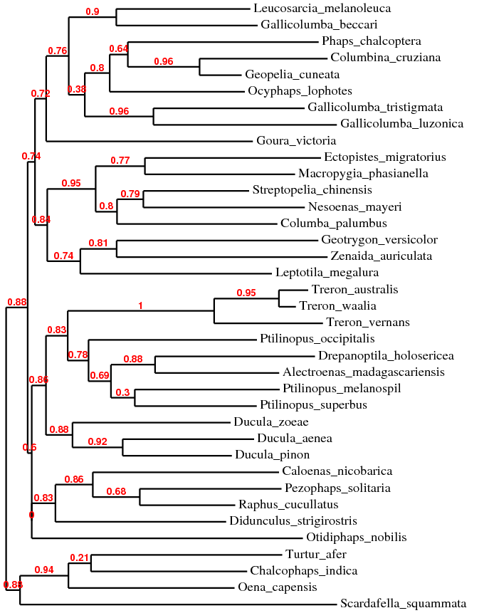

Which species is most closely related to the Dodo?
Pezophaps solitaria (Rodrigues Solitaire)

Which species is the next most closely related to the Dodo?
Caloenas nicobarica
Next you will compare your tree to the tree in the article for which this data was generated.
- Go to Google Scholar (http://scholar.google.com/).
- Using the information you recorded on Page 5, find and download the journal article.

Is the tree in the paper the same as yours?
No

Which species is most closely related to the Dodo according to the paper?
Pezophaps solitaria (Rodrigues Solitaire)

Did the authors use the same statistical method (maximum likelihood)?
Yes

How many genes did the authors use to generate their tree?
2

According to the paper, in which region (Australian, African/Madagascan, Asian/Southeast Asian, Mascarene Island, or New World) do the closest relatives to the Dodo and Rodrigues Solitaire reside?
Asian/Southeast Asian

Using the tree in the paper, on which continent did the ancestor of the Dodo most likely live?
Asia

How do the authors suggest the Dodo and Rodrigues Solitaire reached their islands?
Island stepping stones

Using the article, GenBank, Google, etc., fill in the empty boxes (make sure the Accession numbers are from the individual used in the article for the cytochrome b gene):
Scientific Name | Common Name | Location | cytb Accession
Alectroenas madagascariensis | Madagascar Blue Pigeon | African | AF483344.1
Caloenas nicobarica | Nicobar Pigeon | Asian | AF483336.1
Chalcophaps indica | Common Emerald Dove | Asian | AF483325.1
Columba palumbus | Common Wood Pigeon | Asian | AF483335.1
Columbina cruziana | Croaking Ground Dove | New World | AF483318.1
Didunculus strigirostris | Tooth-billed Pigeon | Asian | AF483343.1
Drepanoptila holosericea | Cloven-feathered Dove | Asian | AF483345.1
Ducula aenea | Green Imperial Pigeon | Asian | AF483331.1
Ducula pinon | Pinon's Imperial Pigeon | Asian | AF483332.1
Ducula zoeae | Zoe's Imperial Pigeon | Asian | AF483333.1
Ectopistes migratorius | Passenger Pigeon | New World | AF483351.1
Gallicolumba beccarii | Bronze Ground Dove | Asian | AF483346.1
Gallicolumba luzonica | Luzon Bleeding-heart | Asian | AF483334.1
Gallicolumba tristigmata | Sulawesi Ground Dove | Asian | AF483319.1
Geopelia cuneata | Diamond Dove | Australian | AF483317.1
Geotrygon versicolor | Crested Quail-Dove | New World | AF483326.1
Goura victoria | Victoria Crowned Pigeon | Asian | AF483320.1
Leptotila megalura | Yungas Dove | New World | AF483342.1
Leucosarcia melanoleuca | Wonga Pigeon | Australian | AF483327.1
Macropygia phasianella | Slender-billed Cuckoo-Dove | Asian | AF483339.1
Nesoenas mayeri | Pink Pigeon | Mascarene Is. | AF483322.1
Ocyphaps lophotes | Crested Pigeon | Australian | AF483323.1
Oena capensis | Namaqua Dove | African | AF483353.1
Otidiphaps nobilis | Pheasant Pigeons | Asian | AF483352.1
Pezophaps solitaria | Rodrigues Solitaire | Mascarene Is. | AF483337.1
Phaps chalcoptera | Common Bronzewing | Australian | AF483324.1
Ptilinopus melanospil | Black-naped Fruit Dove | Asian | AF483328.1
Ptilinopus occipitalis | Yellow-breasted Fruit Dove | Asian | AF483330.1
Ptilinopus superbus | Superb Fruit Dove | Asian | AF483329.1
Raphus cucullatus | Dodo | Mascarene Is. | AF483338.1
Scardafella squammata | Scaled Dove | New World | AF483347.1
Streptopelia chinensis | Spotted Dove | Asian | AF483341.1
Treron australis | Madagascar Green Pigeon | African | AF483349.1
Treron vernans | Pink-necked Green Pigeon | Asian | AF483321.1
Treron waalia | Bruce's Green Pigeon | African | AF483350.1
Turtur afer | Blue-spotted Wood Dove | African | AF483348.1
Zenaida auriculata | Eared Dove | New World | AF483340.1
Phylogenetic Tree 2
You will build a phylogenetic tree using the data from the 12S rRNA gene.
- Using GenBank, find the sequence data for Accession AF483301.1
- Copy the FASTA sequence and paste at the end of your 12S file (you may want to change the name to match the format of the rest of the file).
- Repeat Steps 1 and 2 for Accession AF483300.1
- Save the file as 12S-2.
- Align the data as before, save the file as 12S-2_aligned.
- Build a tree as before, using the 12S-2_aligned file.

Draw your tree:
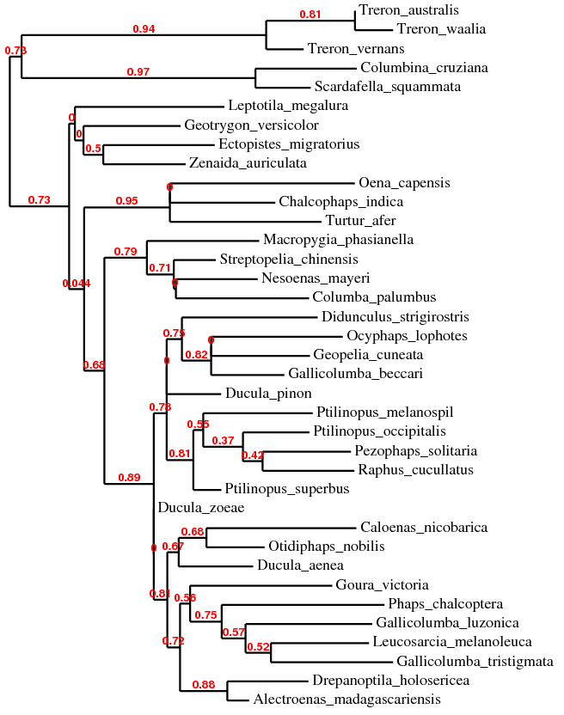
Is this tree the same as your first tree?
No

Would you expect it to be? Why or why not?
Not necessarily, different genes have different evolutionary histories.

Is it the same as the tree in the article?
No

What are some possible reasons that it could be different?
The authors used two genes to generate the tree while we used an individual gene. Also, while the authors used the same method (maximum likelihood), the parameters and evolutionary models are different.

