Week 14 - Hemoglobin Lab Activity Sheet - TA KEY

1. Locality data: Record the state and specific locality for the six specimens.

Table I. HBA amino acid variation results table. Position refers to position in amino acid sequence, translated from HBA-T1 gene.
Sample Name | Pos. 50 |  | Pos. 57 |  | Pos. 60 |  | Pos. 64 |  | Pos. 71
Total number of each amino acid

2. Draw pie charts for each variable HBA position. The pie chart should demonstrate the proportion of each amino acid variant (e.g. Histidine or Proline) in the population:
- Black in fig. indicates suggested pic for TA to draw on whiteboard.
- Red indicates what students are responsible for adding. If missing a group in your class, provide missing solutions.
- Make sure that the labeling of the circles are consistent – high should be one color, low should be another color
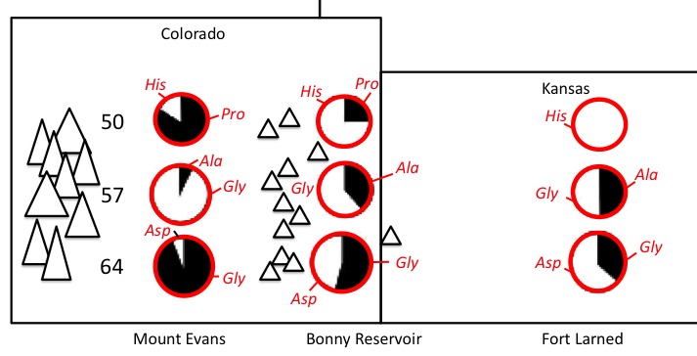
3. Make a hypothesis about how amino acid replacements impact hemoglobin function. In your hypothesis, be sure to address why the Hb-O₂ binding affinity is different in P. maniculatus at different elevations as reported by Storz (2007, J. Mammalogy).

Hypothesis favored by Storz (2007, J. Mamm.) is that the amino acid replacement at pos. 64 in high elevations (Gly) results in reduced steric hinderance for active site in hemoglobin (where O2 binds to heme group). The ancestral allele at pos. 64, Aspartic acid, has a large, polar R-group that likely blocks the O2 entrance to the active site. But there are other possible hypotheses!

4. How would you test your hypothesis? (Hint: Hb-O₂ binding curves!)

Strong approach would be to construct the Hb-O2 binding curve for each replacement, holding all other sites equal. For example, what happens to the Hb-O2 binding curve when only site 64 is changed to the high altitude replacement and the other four sites are held at the low altitude allele? Does the P50 change?

5. If an organism has the mutations that you have found associated with high-elevation populations, which way will that shift the oxygen binding curve? It may help to draw an Hb-O₂ dissociation curve that shows Hb-O₂ binding for both low and high elevation deer mice.

Left-shift, decreased P50, higher Hb-O2 affinity.

6. At what stage in O₂ transport within the body (Fig. 5) will the performance difference between the low elevation and high elevation HBA alleles be greatest? Put another way, at what stage in O₂ transport will high elevation mice have an advantage over low elevation mice when both are at a low environmental partial pressure of O₂. Justify your answer.

A left-shifted Hb-O2 binding curve results in increased Hb-O2 affinity - this change is MOST SIGNIFICANT at the blood-lung barrier in the O2 transport system. So high elevation mice will be able to bind O2 diffusing across the blood-lung barrier more efficiently than low elevation mice when the partial pressure of O2 is low.

7. Generate a list of the ways in which hemoglobin-oxygen binding affinity could be modified by changing the primary sequence of the molecule. Include if the modification is likely to result in a right or left shifted Hb-O₂ binding curve. Where in Fig. 5 would your modification make the most biologically significant impact?
Direction of Hb-O2 shift and transport stage depends on details of modification - ask students to explain their rational. Left-shifts will impact at blood-lung barrier. Right-shifts will deliver more O2 to tissues. Some suggested answers below but not complete or mutually exclusive - students could come w/ others!
 | Modification: | Direction of Hb-O₂ curve shift: | O₂ transport stage impacted:
1. | steric hinderance for active site
2. | subunit interactions - conformational consequences
3. | allosteric affector sensitivity  (DPG, IPP, CO₂, KCl, H⁺)
4. | pH sensitivity (Bohr effect)
5. | temperature sensitivity

8.
- Report the P₅₀ for HBB allele βII (Fig. 6C) stripped, DPG present, KCl present and DPG+KCl present. Recall that the P₅₀ is the partial pressure of oxygen (PO₂) for which 50% of the hemoglobin in the sample is saturated.

αI, αIII/βII P₅₀ stripped:

αI, αIII/βII P₅₀ DPG:

αI, αIII/βII P₅₀ KCl:

αI, αIII/βII P₅₀ DPG+KCl:

- What are the independent and combined effects of adding the allosteric affectors DPG and KCl? Is affinity increased or decreased compared to the stripped protein? Where in the body would the impact of this shift have the greatest impact (lungs, capillaries, mitochondria)?

DPG:

KCl:

DPG+KCl:

- Compare the P₅₀ for HBB allele βI (graph A) to the P₅₀ for allele βII. Which state (stripped, DPG etc.) differs the most?
αI, αIII/βI P₅₀ stripped:

αI, αIII/βI P₅₀ DPG:

αI, αIII/βI P₅₀ KCl:

αI, αIII/βI P₅₀ DPG+KCl:

- In terms of an organism, what is the consequence of having βI or βII? Using the result of HBA as an example, which allele is likely to be found in a high elevation animal?

- Do you think that the differences between βI and βII oxygen binding capacity originate from just a few amino acid changes or a large number of amino acid changes in the β subunit primary sequence? Why? How would you test your hypothesis?

9.
- What is the essential question you will test?

- Write a hypothesis that demonstrates how you will test your essential question.

- What variables, environmental and biotic, will you measure in your study? Justify your selection of these variables.

Students at this point should cue into elevation and/or the partial pressure of O₂ as an important environmental variable.

- For your study, you need to select 6 sampling localities where you will collect data on deer mice populations. Recall that for the Storz et al. (2009) study, they chose 2 sites that were 220 miles apart. What would you do? Remember to think carefully about what environmental variables are important to your study, how population history of the deer mice may be important and what you gain from dense sampling vs. having a wide geographic scope.

In this case, high/low comparisons on independent mountain ranges can serve as replication, but that isn't the only good study design!

10. Are there any tissues for you to conduct your experiment? How many samples do you think you need from each locality? (Hint: keep good notes on these results, you'll need them for your homework!)

11.
- Describe quantitatively how the distribution of the haplotype d¹d¹ changes across the 9 sample sites (Fig. 10). In which populations is d¹d¹ most abundant? Least abundant?

- Clinal analyses demonstrate the rate of transition between one state to another across a transect, with steeper transitions indicating either natural selection or recent contact between two independent clades (groups with shared genetic history). In Fig. 11, the analysis shows the transition from no d¹d¹ present in a population (frequency = 0) to only d¹d¹ (frequency = 1) present across altitude. Describe how d¹d¹ frequency changes across altitude. Is the transition rapid or gradual?

- Use Figs 6, 10 and 11 to evaluate the evidence for natural selection acting on the hemoglobin β subunit in deer mice. If natural selection is occurring, what do you think the mechanism is (what is the environmental pressure that results in selection?)? How does the sampling design (sample sizes per population and populations selected) of the Storz et al. 2009 and Storz et al. 2012 papers impact your conclusion?

- What remaining questions do you have about natural selection on HBB in deer mice? Are you satisfied with the geographic scope of the studies presented? With the phylogenetic scope? Are you certain of the mechanism causing natural selection - if not, why not?

